**CS 202 HW2**

Name: Fatih Sevban Uyanık

Id: 21602486

**Q1)**

**A)**

**Preorder:**  1, 2, 4, 7, 8, 5, 9, 10, 12, 13, 3, 6, 11

**Inorder:**  7, 4, 8, 2, 9, 5, 12, 10, 13, 1, 3, 6, 11

**Postorder:** 7, 8, 4, 9, 12, 13, 10, 5, 2, 11, 6, 3, 1

After inserting elements

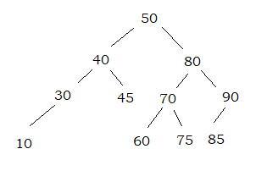

After deleting elements

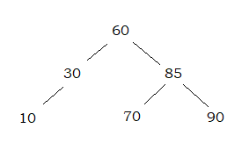

**Q3)**

**addNgram:**

In the worst case, the tree can be linear. In this case, the element to be inserted might need to come at the very bottom of the tree. In this case, addNgram function has a worst case complexity O(n).

**printNgramFrequencies**

Since I am doing an inorder traversal while printing the frequencies, the running time complexity of printNgramFrequencies is O(n).